Treasures of the Sephardic Kitchen – Yesterday, Today and Tomorrow
With Susan Barocas and Stella Hanan Cohen
Prepared for Limmud Boston, January 2022

Recipes from Susan Barocas

The Sephardic foods in my family were passed down to me first by my father, whose parents were from the Ottoman Empire, descended from Jews who fled Spain’s Inquisition. As an adult, I have pursued learning as much as I can about Sephardic food, culture and history from many people. I am passionate about preserving Sephardic heritage and passing it on to my son and others, seeing myself as one link in a long, incredible history.

Chickpeas with Onions, Honey and Pomegranate

Chickpeas, garbanzos in Spanish, have been grown in the Iberian Peninsula for centuries, an abundant vegetarian source of protein appreciated by the Jews of Spain who first arrived with the Romans (who loved their chickpeas), in the 3rd century BCE. Sephardim then and now use chickpeas in soups, vegetable casseroles, stews with meat or fish and in dishes on their own such as this one. This dish features a savory and sweet combination of flavors and includes vinegar, an ingredient often used by the Sephardim in vegetable dishes and now a popular part of Spanish cuisine. Serve as a main or side dish on its own or over rice, quinoa or other grains. The recipe is adapted from A Drizzle of Honey: The Lives and Recipes of Spain’s Secret Jews and from my own research into the food of the Jews of Spain.

Serves 4-6

2 medium onions, diced
2 tablespoons olive oil
1/2 teaspoon grated fresh ginger
1/4 teaspoon ground cloves
1 tablespoon honey
1 cup pomegranate juice
3 teaspoons pomegranate molasses
1 teaspoon wine vinegar
2 15-ounce cans chickpeas, drained, or 3 cups cooked chickpeas
1/2 teaspoon salt
1/4 teaspoon black pepper
Seeds and juice of 1 pomegranate
Chopped parsley and a drizzle of pomegranate molasses for garnish (optional)

In a large pan, heat the oil over medium. Sauté the onions about 12-15 minutes, stirring occasionally, until soft and sweet, just starting to brown. Add the ginger and cloves to the pan and mix for a minute, letting the spices begin to release their aromas. Add the honey, pomegranate juice, molasses and vinegar to the pan. Stir well to blend. Add chickpeas, salt and pepper and stir well.
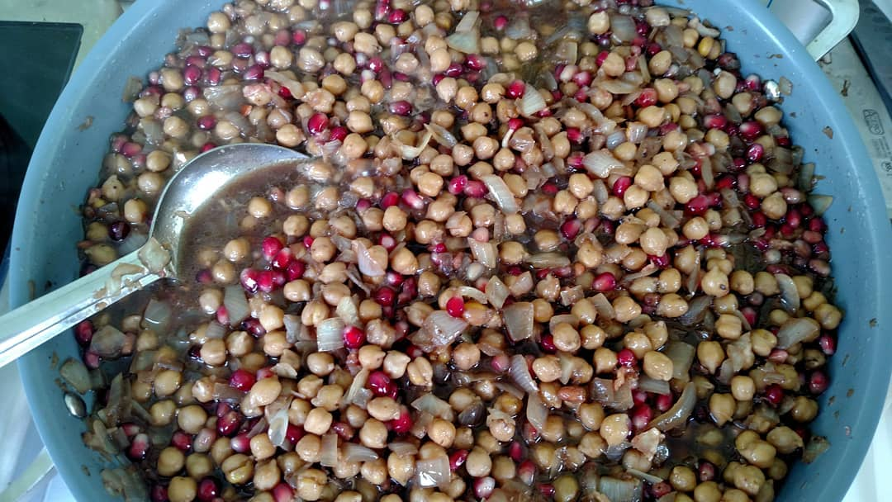
Simmer for 10-15 minutes to heat through and blend flavors. Adjust salt and pepper to taste. Add the pomegranate seeds and cook another minute or two. Serve hot, cold or at room temperature. Drizzle with pomegranate syrup and/or sprinkle with parsley before serving if desired.

Tip: Very lightly oil the measuring spoons for the honey and pomegranate molasses to get them to release easily.
Sephardic Almond Cookies
Marochinos

Cooking with ground nuts and nut pastes was popular in medieval Jewish and Islamic cultures across Iberia, North Africa and the Mediterranean. Jews became known in Spain for the wonderful sweet confections made with almonds which grew well in Spain. At the time, beaten eggs and egg whites were the primary way to leaven baked goods. These cookies, perfect for Passover, are based on a recipe carried by Jews when forced by the Inquisition to leave Spain. Similar to a macaroon, they bake up crispy outside, chewy inside and totally addictive any time of the year.

Makes about 24 cookies

2 cups almond meal*
1/3 cup granulated sugar
Pinch of salt
1 teaspoon cinnamon (optional)
5 large egg whites
1 teaspoon almond extract
1 teaspoon vanilla extract
About 24 whole almonds or almond slices
Confectioners' sugar for dusting (optional)

Preheat oven to 325 degrees. Make sure the oven racks are in the top and bottom thirds of the oven. Line 2 large baking sheets with parchment paper or lightly grease the pans.

Use a whisk to combine almond meal, sugar, salt and cinnamon, if using, in a mixing bowl. In a separate mixing bowl, lightly beat the egg whites and extracts about 20 seconds just until foamy. Add the almond mixture and stir together with a wooden spoon about 10-15 seconds just until the mixture is well blended, being careful not to overmix.

Drop the mixture by the teaspoonful about 2 inches apart on the prepared baking sheets, using another teaspoon to help drop each cookie. Use the back of a spoon to gently round the edges and flatten just slightly the top of each marochino. Very gently press one whole raw almond or an almond slice onto the center of each.

Bake for 15 minutes, then switch the baking sheets to the other rack, also turning each around 180 degrees for even cooking. Bake about another 12-15 minutes or until lightly golden brown on bottom and starting to get a few lightly golden brown highlights on top. Cool on the sheets a few minutes, then transfer to a rack and cool completely. Marochinos keep up to a week in an airtight container in a cool, dry place with the layers of cookies separated by waxed or parchment paper. They also freeze well when packed this way. Dust with confectioner’s sugar before serving.
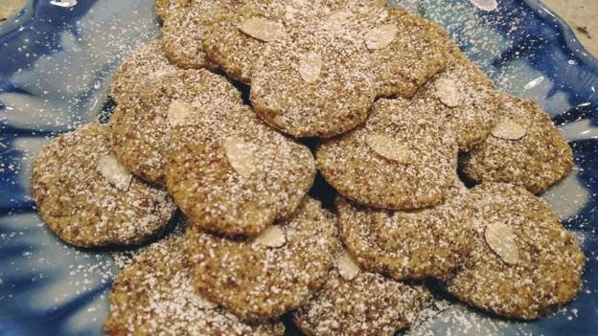
Tip: *Almond meal can be purchased already prepared, usually from unpeeled almonds. It is not as finely ground and powdery as almond flour, but still has a little texture to it which gives the marochinos a good texture. You can make your own almond meal by grinding whole raw almonds (peeled or unpeeled) in your food processor to a texture a bit like sand.

Recipes from Stella Hanan Cohen

As a descendent of the Jews of Rhodes Island, I was immersed and fascinated growing up in Zimbabwe with our unique Rhodesli food and traditions. I felt compelled to preserve our family recipes in a cookbook Stella’s Sephardic Table with the flavors of our gastronomy steeped in antiquity with origins from Spain and the Ottoman Empire. I am dedicated towards perpetuating and revitalizing our Judeo-Spanish food and culture to the next generation and with my children and grandchildren who live in New York.

Sephardic Spinach (Swiss Chard), Feta & Potato Bake
Quajado de pazi kon kezo I patata (sfongo)

Quajado is a popular Sephardic crustless vegetable, egg and cheese quiche-like baked casserole. The Ladino word ‘kuajado’ is derived from the Spanish ‘cujada’ meaning coagulated.
The Sephardim of Rhodes Island made a version called ‘sfongo’ characterized with small mounds of mashed potato and cheese interspersed on a bed of shredded spinach, (I prefer to use Swiss chard), and a combination of Greek cheeses and potato. I have added fresh herbs, scallions and creamy cheese to the traditional recipe for that extra depth of flavor and texture.
‘Sfongo’, with its crisp burnished bronze crust on a moist comforting gratin, is ideal served warm cut in squares for brunch or as a light gluten-free meal with a side of Greek salad.
I hope this becomes a favorite dish with you! Buen Provecho!
1lb 2oz fresh Swiss chard, stalks removed, washed, dried and finely shredded
1lb 2oz potatoes, unpeeled
3-4 scallions (spring onions), chopped
½ cup chopped flat-leaf parsley
¼ cup fresh dill, chopped
1 cup quality feta, crumbled
1 cup full fat ricotta or similar Greek cheese
1½ cups grated kashkaval or similar hard cheese
salt and freshly ground black pepper
7 large eggs, lightly beaten

To combine with mashed potato:
2 large eggs, lightly beaten
½ cup grated kashkaval
a pinch of baking powder
1 tbsp full milk

For the topping:
½ cup grated kashkaval cheese; 2 tbps unsalted butter, diced

Prepare the potatoes: Put the potatoes in a pan with enough cold salted water to just cover. Bring to a boil. Cover, reduce the heat and simmer for 30-40 minutes or until tender when pierced with a knife. Drain and whilst still hot (using a fork to hold the potato steady and tongs to peel off the skin), peel and return to the pan for about 1 minute to dry off any excess moisture. Put through a potato ricer. Divide the potato mixture into two thirds and set aside the remaining third.

Preheat the oven to 350ºF. Grease a 14x10in baking dish with oil and place in the oven.

Beat 7 eggs in a mixing bowl.

In a very large bowl, and using your hands, mix the Swiss chard with two thirds of the mashed potato, scallions, parsley, dill, feta and ricotta cheese and 1½ cups of grated kashkaval, salt and pepper. When evenly incorporated add the 7 beaten eggs and combine well.

In another bowl combine the remaining third of the mashed potato with 2 beaten eggs, the remaining ½ cup kashkaval cheese, a pinch of baking powder and the milk. Season with salt and pepper. Mix well.

Remove the heated dish from the oven and spread the Swiss chard and potato mixture evenly.

With a spoon create golf ball sized hollows in the layer of the Swiss chard and potato mixture spacing them evenly in rows about 1in apart. Fill with teaspoonfuls of the potato and cheese mixture, forming small mounds.

Sprinkle with cheese and dot with knobs of butter. Bake for 50 minutes or until the top is crusty and golden brown and the quajado is set. Serve warm, cut into squares.
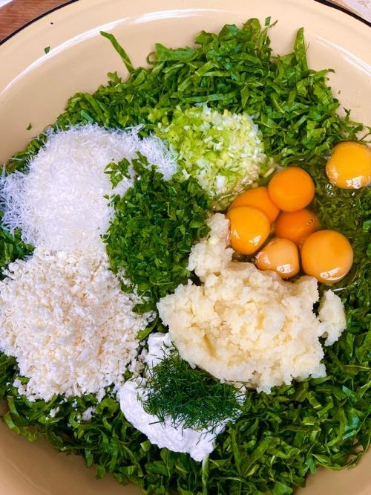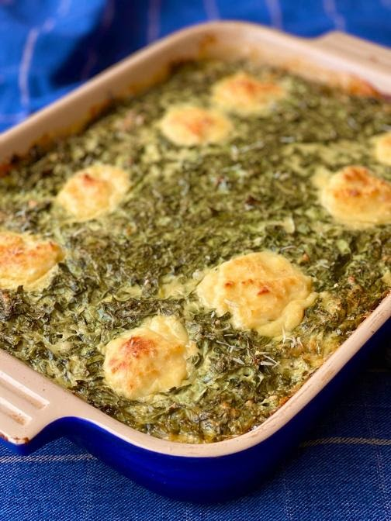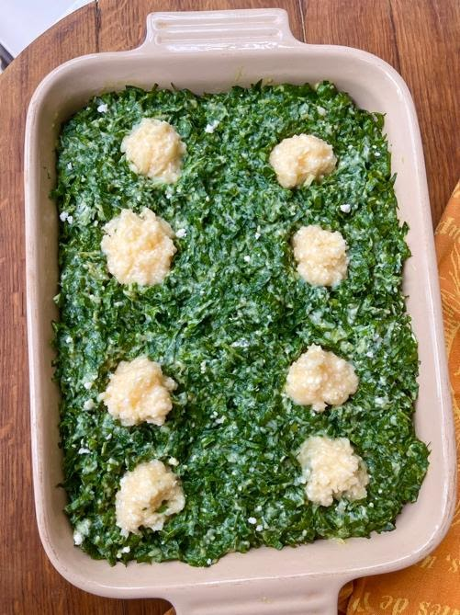

Almond Shortbread
Kurabyes

A profusion of almond confection with origins from Moorish Spain have become an intrinsic part of our everyday sweet offerings. Kurabyes, derived from ghriba (ghouyeba), are irresistible crisp shortbread cookies with toasted ground almonds, a hint of ouzo, fragrant with orange blossom water and generously drenched in powdered sugar.

When the Sephardim in exile settled in Rhodes Island they continued to make these melt-in-the mouth treats very similar to Greek kourabiedes. I have added an earthy dimension to my original traditional recipe with tahini paste and for that extra crunch toasted sesame seeds. I hope you enjoy this super easy to make addictive treat.
1 cup unsalted butter, at room temperature
¾ cup confectioner’s sugar, plus extra for dusting
1 tsp vanilla extract
½ cup sunflower oil
2 tbsp tahini paste
1 tbsp ouzo or brandy
1 cup blanched almonds, *lightly toasted and ground
3 cups all-purpose flour
¼ cup cornstarch
¼ tsp baking powder
a pinch of salt
1 tbsp sesame seeds, toasted

For shaping:
1 tsp orange blossom water diluted in 1 cup water

For topping:
20 blanched slivered almonds or pistachios

Preheat the oven to 325ºF. Line 2 baking trays with baking paper.

Beat the butter on medium speed in the bowl of an electric mixer for about 8 minutes, until pale and creamy. Gradually add the confectioner’s sugar and vanilla extract and beat for 2 minutes. Beat in the oil and tahini paste and ouzo or brandy.

Stir in the ground almonds, the sifted combined flours, baking powder and sesame seeds, gradually working in lightly with your hands until a very soft dough forms. Be careful not to overwork it.

Pinch off about 20 pieces of dough. Moisten your hands with diluted orange blossom water and shape into balls. Squeezing with both forefingers and thumbs shape into triangles about 1½in wide and ½in in height. Arrange on the prepared baking trays leaving some space between them as they spread while baking. Press in slivered almond or pistachio in the center of each biscuit.

Bake for about 20 minutes or until they are just beginning to color. They should be pale, slightly cracked on the top and barely golden around the edges. Do not overcook. Let cool on the baking trays for 5 minutes before removing with a metal spatula and set on wire racks. To serve, dust generously with confectioner’s sugar and stack on a platter.

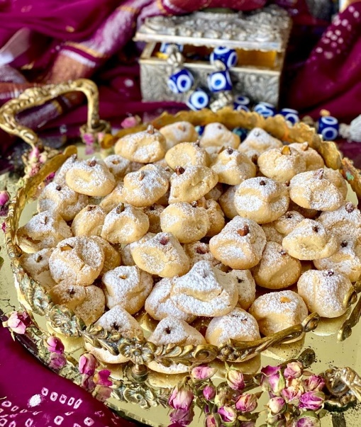
Stella’s Hints:
- *Grind the toasted almonds finely but not to a powder – they should be like sand with coarser bits giving the biscuit more crunch.
- They will keep for up to 2 weeks in an airtight container in a cool dry place.

